Install and configure

Install Java (JDK) 7
Download and install Java 7 at: http://www.oracle.com/technetwork/java/javase/downloads/jdk7-downloads-1880260.html

Install Maven 3
- Download Maven 3.2.1 at: http://mirrors.digipower.vn/apache/maven/maven-3/3.2.1/binaries/apache-maven-3.2.1-bin.zip
- Unzip to D:\Software\. It will look like below:
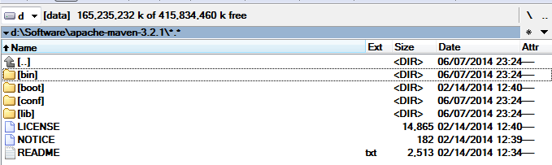

Configure Maven
Configure location of Local Repository
Modify D:\Software\apache-maven-3.2.1\conf\settings.xml file, adding below line right after the open <settings> tag:
<localRepository>D:\Maven Repository</localRepository>

Create Environment variables:
Click “Start” menu → Right click “Computer” → Properties
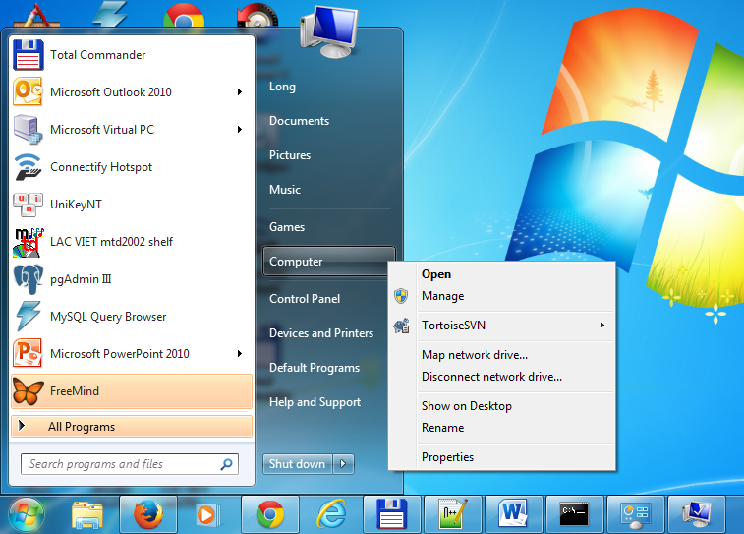
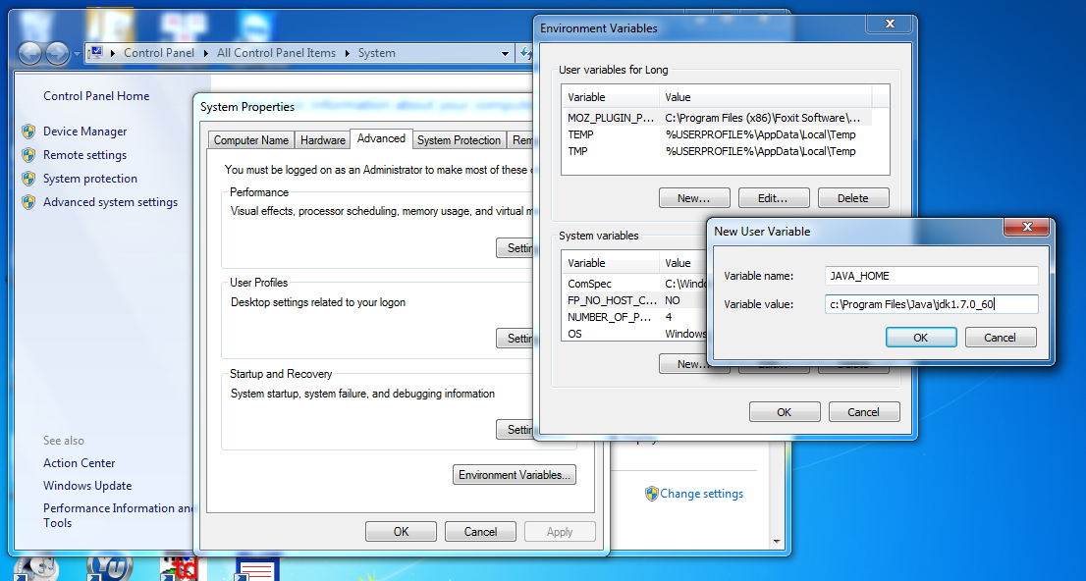
- JAVA_HOME = location to JDK (NOT JRE) folder. Ex: C:\Program Files\Java\jdk1.7.0_60
- MAVEN_HOME = localtion to Maven folder. Ex: D:\Software\apache-maven-3.2.1
- Add Maven’s bin folder to the PATH environment variable: PATH = ….; % MAVEN_HOME%\bin

Verify Maven configuration
Open command prompt and run this command:
mvn –version
You will see something like picture below: 